Whites Creek High School
Library Media Center
Expectations
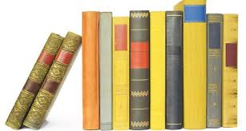
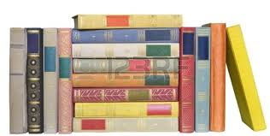

- Students need a library pass and should sign in when they arrive.

- Students are to use the computers for academic purposes only
(printing 10¢/page).

- Students may bring re-closable beverage containers into the library. No food, please.

- Be considerate:
- Voices should be kept at a quiet, conversational level.
- Disruptive or unsafe behaviors, physical or verbal, are disrespectful to others
- Treat library materials and equipment with care
- Clean up after yourself—exit out of computer programs, throw away trash, return books, push chairs in, take personal belongings

